Culture Collage Project
DUE DATE 10/2

Create a collage on the provided cardstock about your culture. Make sure to use the culture questionnaire we filled out in class.
Your collage should have the following elements:
- Ethnicity (where your family is from) and Language
- Religion and Beliefs
- Customs and Traditions (including holidays, religion, clothing, food)
- Education (favorite subjects, favorite colleges, plans after high school, etc.)
- Economic Activity (current job, future jobs you want)
- Art and Music
- Technology (things you want or use on a daily basis)
- Recreation (sports, activities, hobbies, etc.)
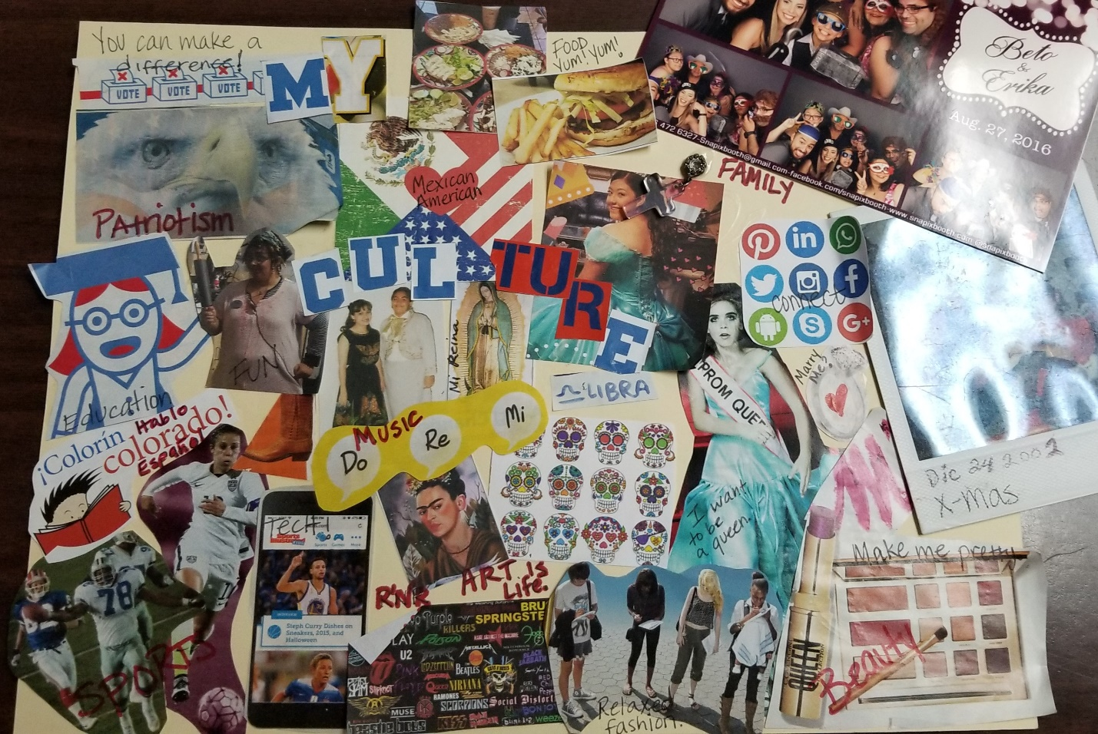
- Other (people or ideas)

Crear un collage en la cartulina proporcionada acerca de su cultura. Asegúrese de utilizar el cuestionario de cultura que hemos completados en clase.

