Spelling Words

1. flat
2. that
3. chat
4. brat
5. scan
6. plan
7. clan
8. *not
9. *white
10. *jump
11. *pretty
12. *said
13. *all

**Study words each night. They will be tested on Friday.**

**If you have any questions please do not hesitate to contact me at:** [acuellar@sharylandisd.org](mailto:acuellar@sharylandisd.org)

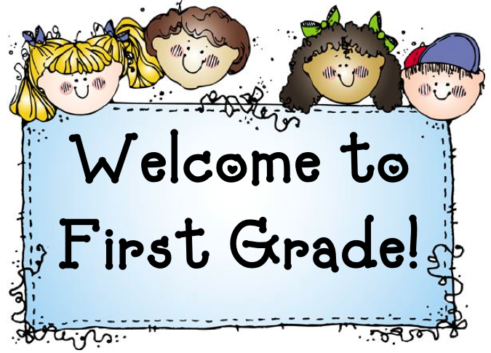

**  Homework  **

**August 25-29, 2014**

**Spelling Homework:** Pick ***one*** spelling activity to complete each night.

Each activity must be completed in the spiral notebook labeled ***“Spelling”***.

Only **4** activities will be chosen each week.

\***Each activity may only be picked once a week.**

##### **1.** Write words 3 times each.

**2.** Rainbow Words – Write your spelling words with a crayon. Trace over each

word again with a different color. Now trace each word one more time with

another color.

**3.** Pick 10 words and write a sentence with each word.

**4**. Take a practice Spelling Test. Write any word you miss 3 times each.

**5.** Pyramid Words- Students are to write each of their spelling words in a

pyramid form. **Example: that: t**

**th**

**tha**

**that**

|  |  |  |  |  |
| --- | --- | --- | --- | --- |
| **Monday** | **Tuesday** | **Wednesday** | **Thursday** | **Friday** |
| **Reading:**  *Nat Can Jump*  *pg. 8-11 & Pam and Sam*  *pg. 13-24*  **Math:** No Homework  **Spelling:** Pick a spelling activity of your choice. | **Reading:**  *Nat Can Jump*  *pg. 8-11 & Pam and Sam pg. 13-24*  **Math:** 1-1  pg. 11-12  **Spelling:** Pick a spelling activity of your choice. | Reading:  *Nat Can Jump*  *pg. 8-11 & Pam and Sam pg. 13-24*  **Math:** 1-2  pg. 17-18  **Spelling:** Pick a spelling activity of your choice. | **Reading:**  *Pam and Sam*  *pg. 13-24*  *Rules at School*  *pg. 26-31*  **Math:** 1-3  pg. 23-24  **Spelling:** Pick a spelling activity of your choice. | **Have a Great Weekend!** |

Weekly Announcements:

1. We will be reviewing the kinder dolch words the 1st six weeks. You will find a copy of the words behind this homework sheet. Please review a few words every night with your child. **Students will be tested at the end of the 1st six** **weeks orally and spelling each word correctly.** If your child has mastered all the Kinder dolch words, there is a copy of the 1st grade 1st semester word list behind it. You may begin studying these words with your child.
2. **\*\*Please keep transportation tags attached to your child’s backpack.**
3. We will begin our guided reading groups next week. Students will be assessed on their reading level and fluency this week.

**Weekly Objectives:**

**Reading:** Character and Setting **Math:** daily enVision Math & Patterns

**Grammar:** Complete Sentences **Spelling:** short a

**Science:** 5 Senses **Social Studies:** School rules & routines